# CS 255 System Design Document Template

## UML Diagrams

### UML Use Case Diagram

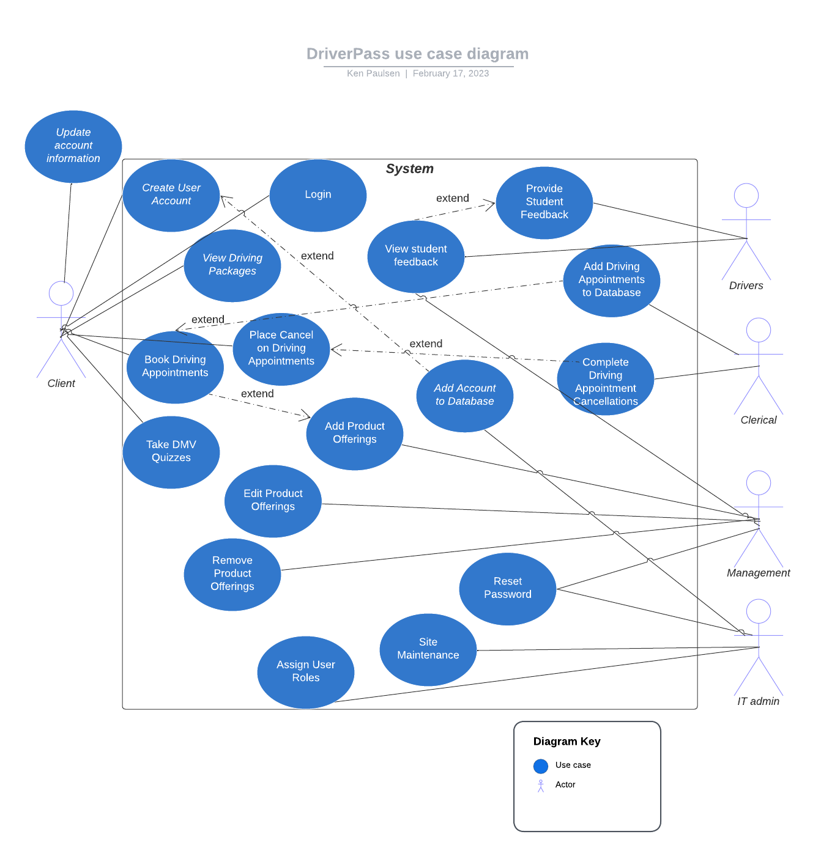

### UML Activity Diagrams

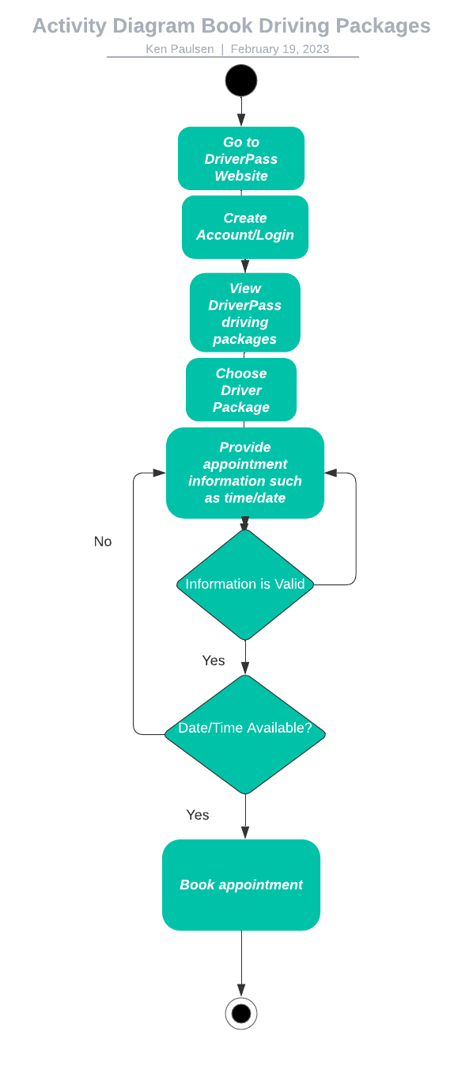

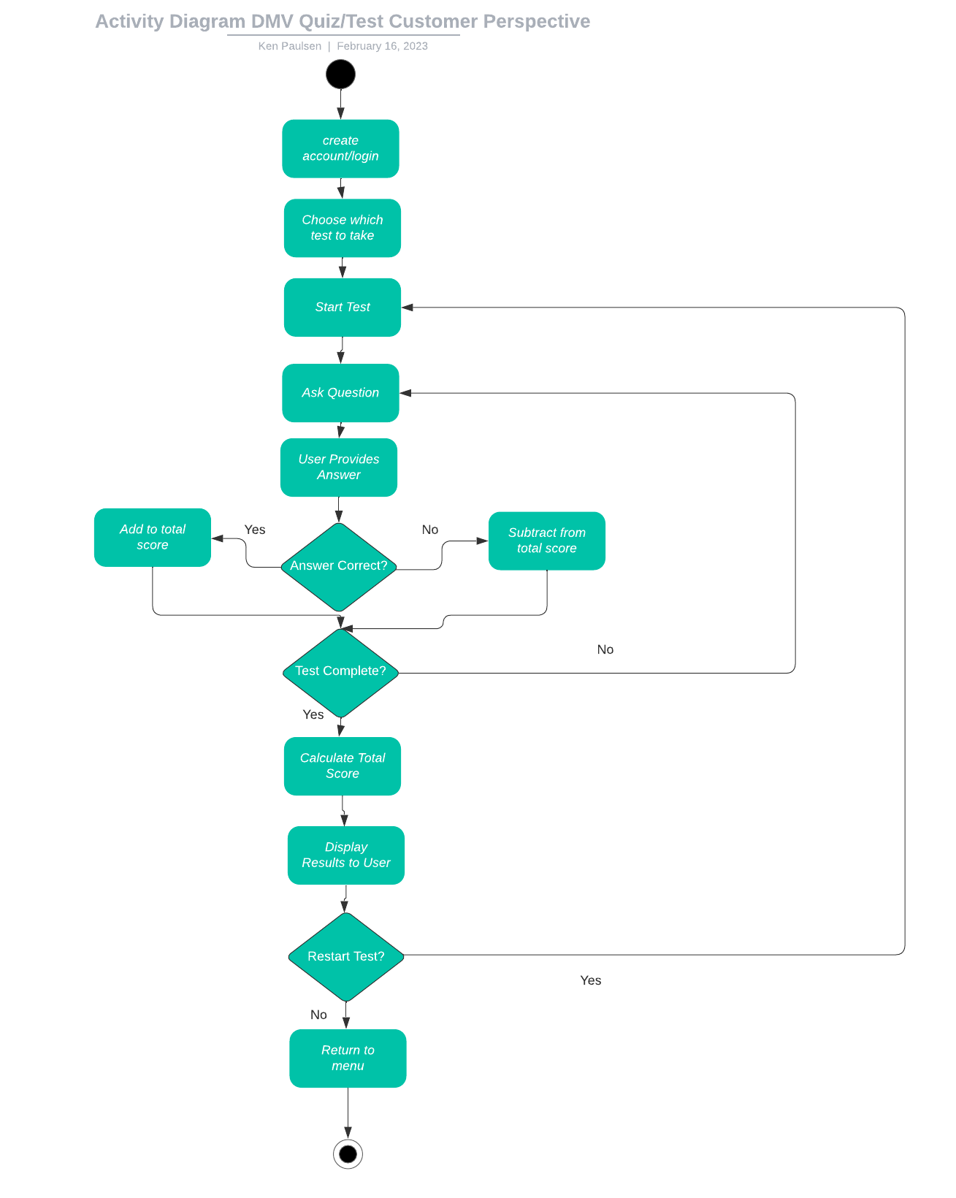

### UML Sequence Diagram

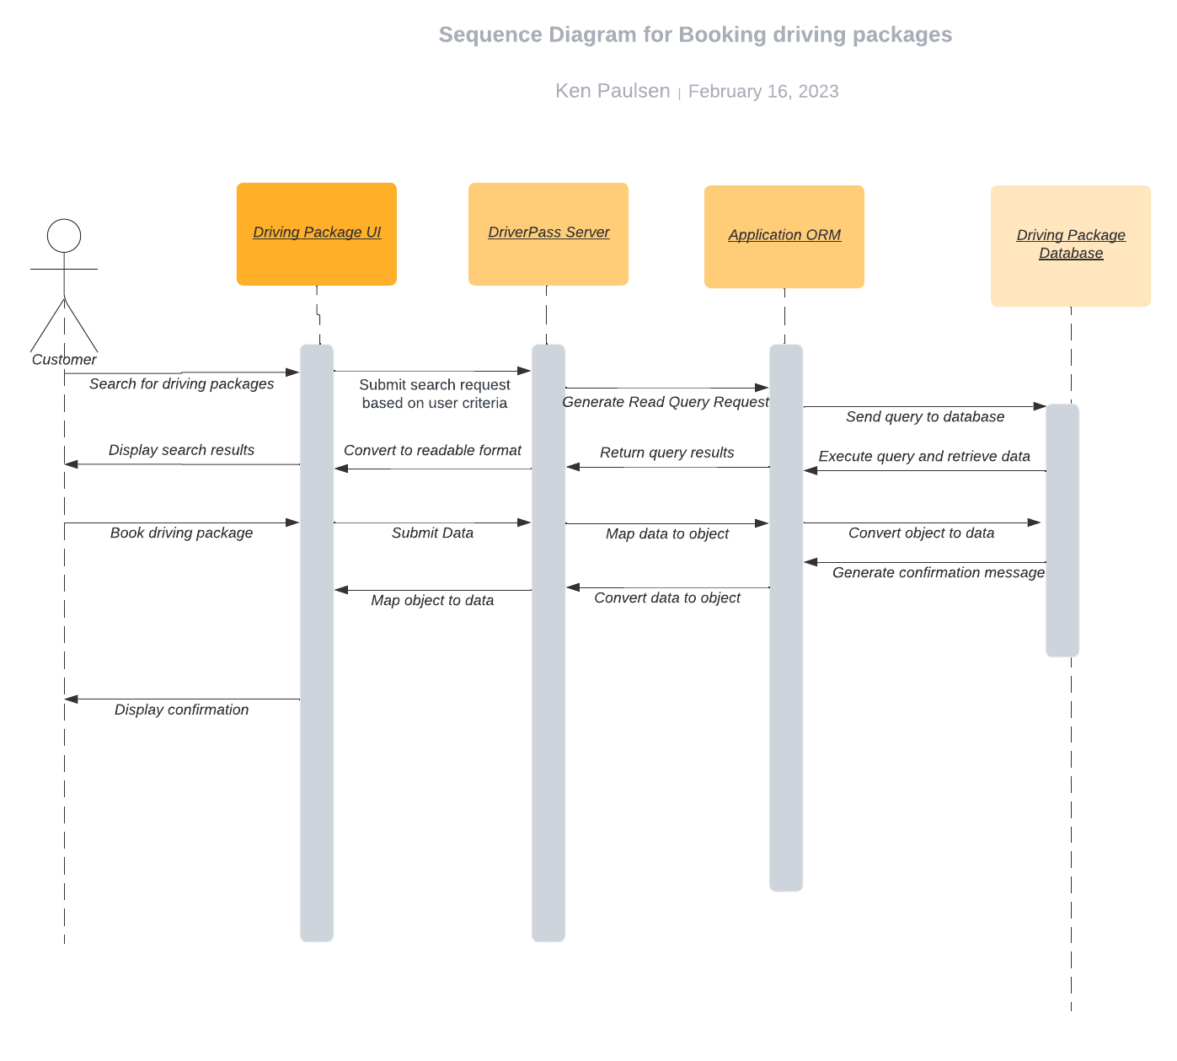

### UML Class Diagram

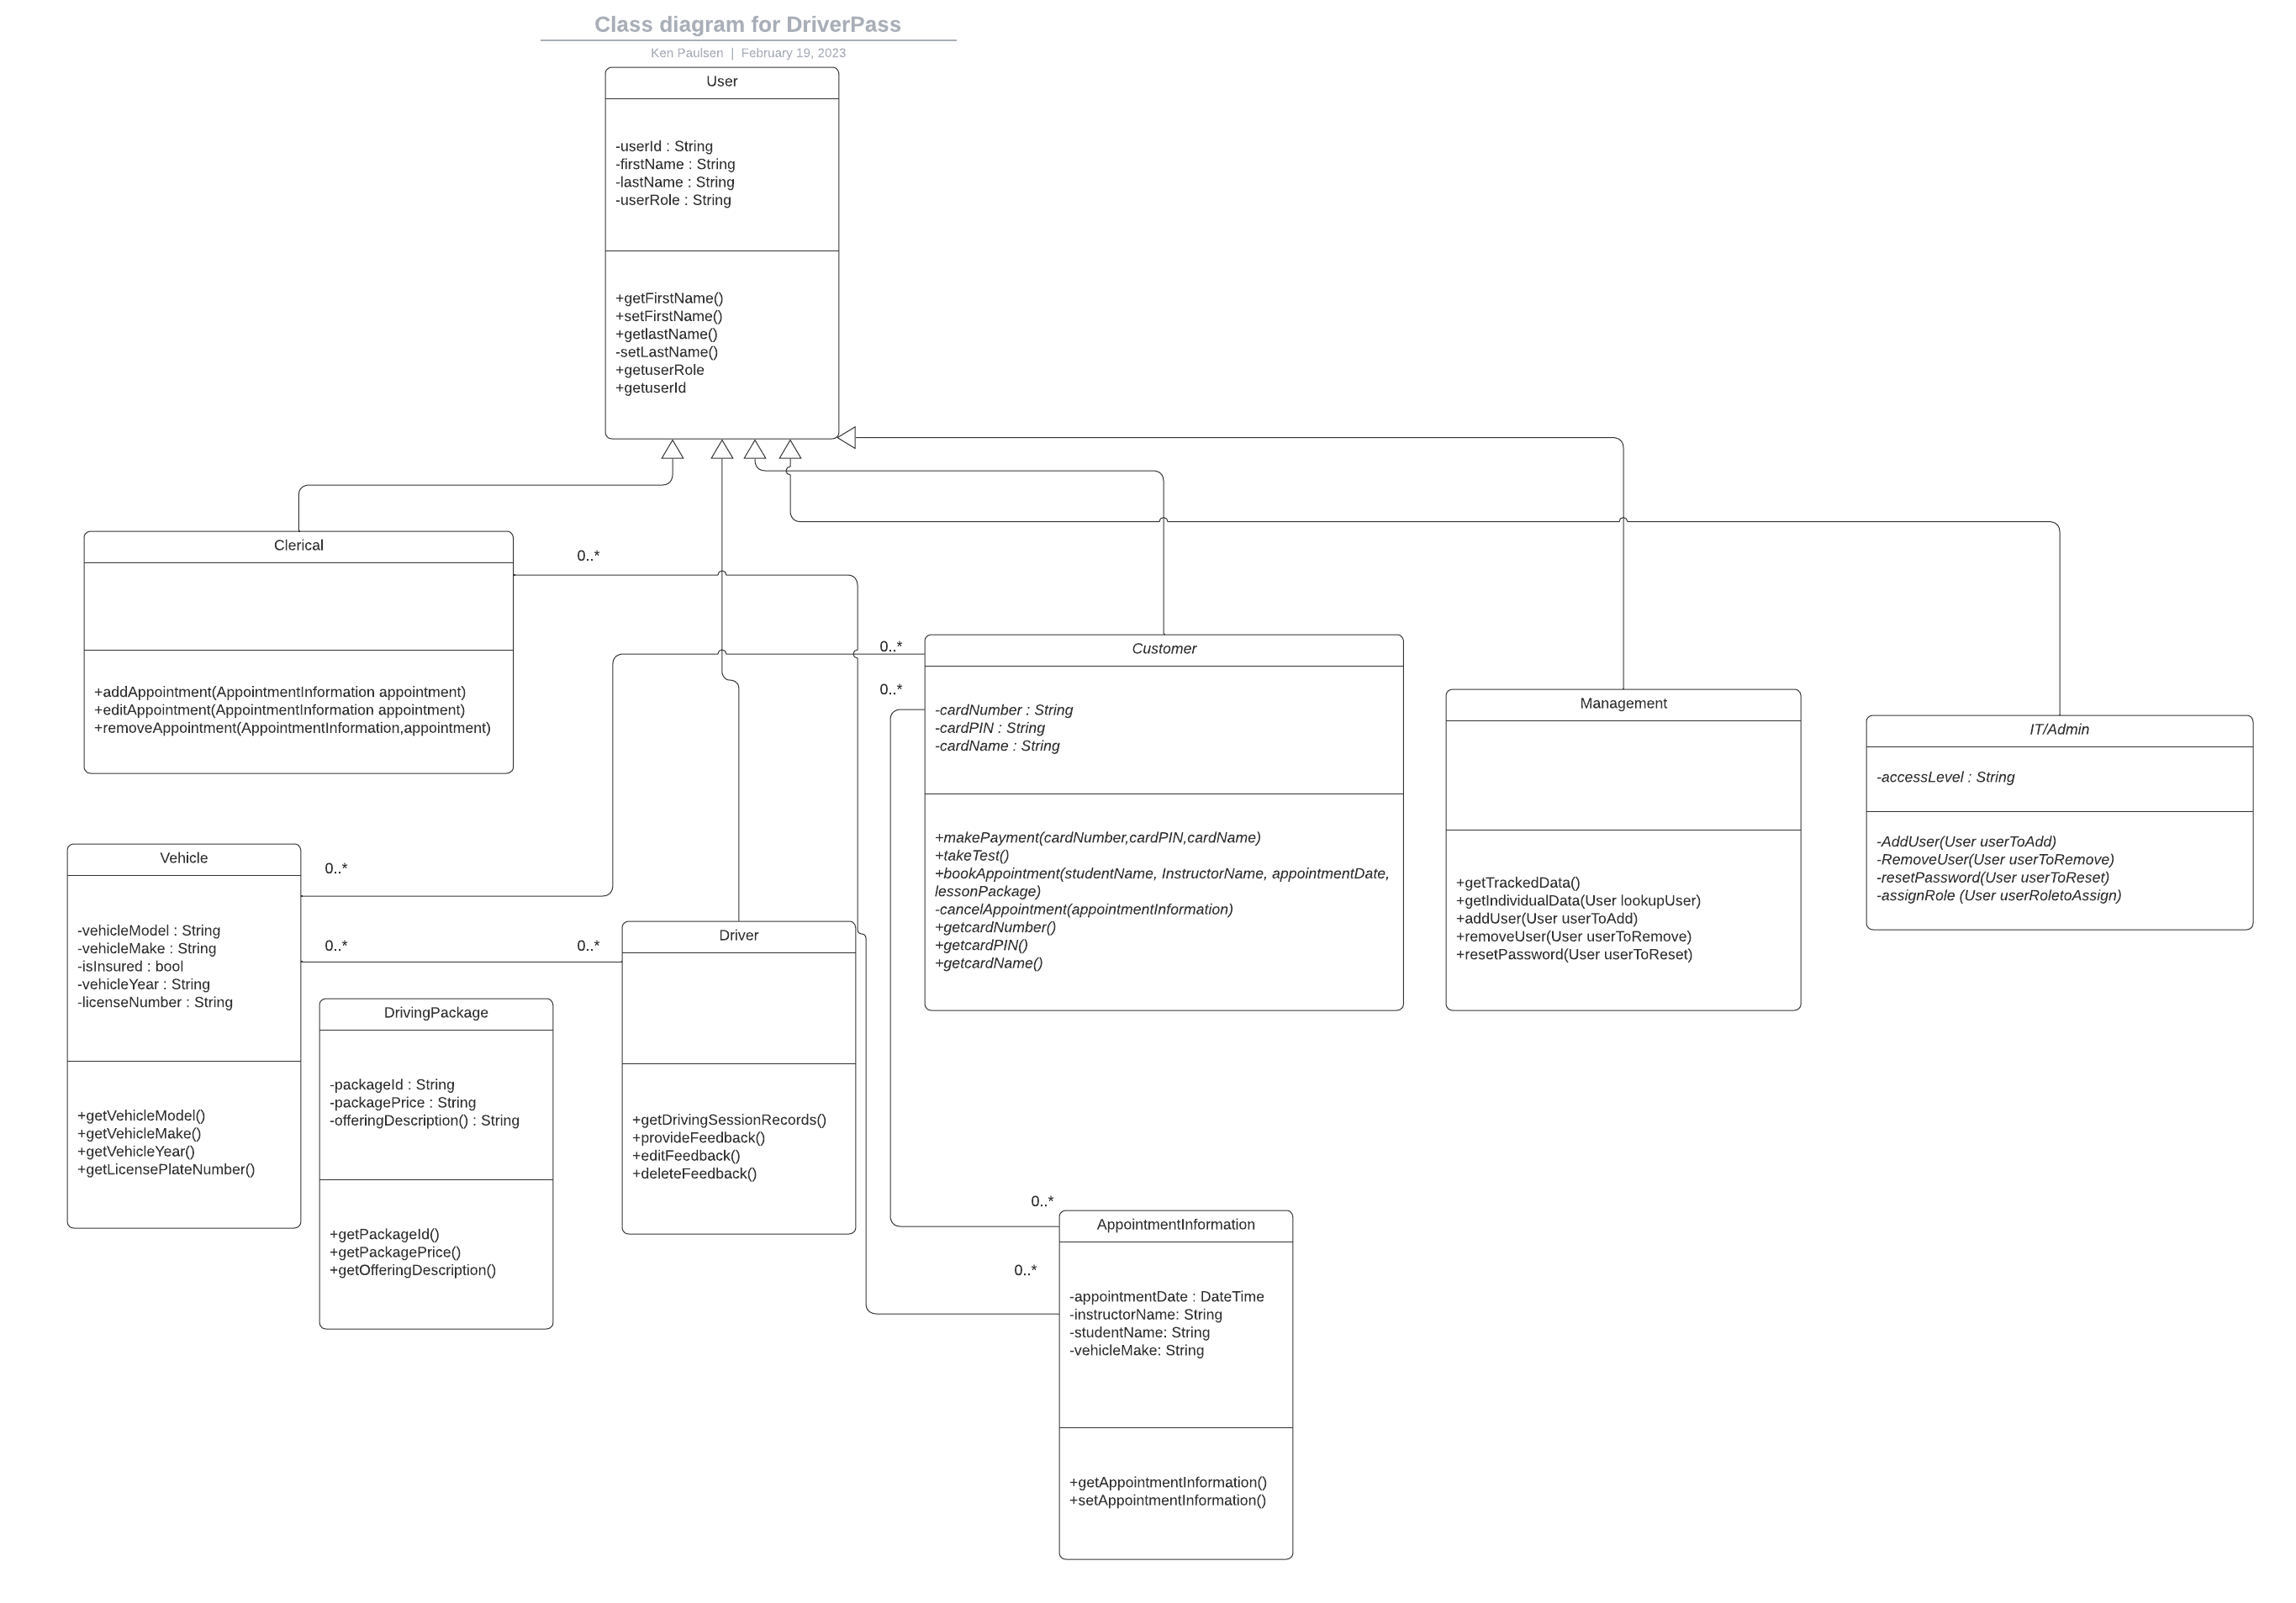

## Technical Requirements

*Based on DriverPass’s needs, this would need be able to run on all major operating systems (Windows, Linux, Mac). The system would also need to be compatible with desktop devices as well as phones and tablets. There would also need to be a database that stores client accounts, a database for driver/employee accounts, a database for online tests/results and another database for driver package appointment information. Since DriverPass would be using a cloud provider for some functionality, they would need to make connections through the provider’s API which would require integration with the main system. This would also mean the application must be able to run off the cloud. The DriverPass application would also need to be able to periodically connect to the DMV database so that their tests can be updated to meet current DMV standards. To reach the optimum amount of users, the application should also support three of the most current versions of each major browser (Chrome, Internet Explorer, Firefox).*

*The system will support multiple versions of the system and its software components. This enables new features to be added to the program over time. The system will also need to track any changes made by users in the system providing details as who made the changes and when. To ensure only those with proper credentials can access sensitive data, the system will assign roles to users based on their credentials. These roles are IT, Management, Customer, Driver, and Clerical. As an example, Drivers can’t access or perform actions on sensitive data contained in the databases. Additional security measures would include checking for valid input (input validation), backing up data with the cloud provider, securely encrypt important data and allow users to reset/recover their passwords.*